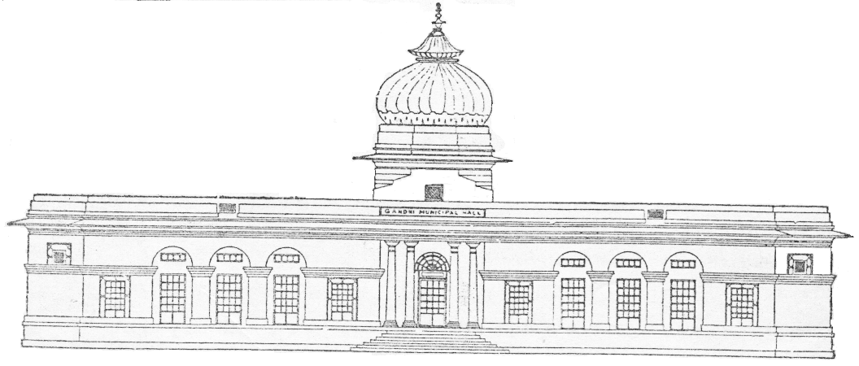 chdkusj uxj fuxe

ßlkyeukFk uxj vkoklh; ;kstuk&izFke pj.kÞ ds Hkw[k.Mksa dk ykWVjh vkoaVu gsrq Js.khokj fooj.k

Ø-la- | Hkw[k.M dk eki | Js.kh
Ø-la- | Hkw[k.M dk eki | vuq-tkfr |  | vuq- tu tkfr |  | lSfud] HkwriwoZd lSfud@ Lora=rk lsukuh |  | jkT;@ dsUnz deZpkjh |  | lkekU;
Ø-la- | Hkw[k.M dk eki | dqy miyC/k Hkw[k.M | LohÑr vkosndksa dh la[;k | dqy miyC/k Hkw[k.M | LohÑr vkosndksa dh la[;k | dqy miyC/k Hkw[k.M | LohÑr vkosndksa dh la[;k | dqy miyC/k Hkw[k.M | LohÑr vkosndksa dh la[;k | dqy miyC/k Hkw[k.M | LohÑr vkosndksa dh la[;k
1- | 15' X 30' | 3 | 147 | 2 | 7 | 4 | 11 | 7 | 16 | 20 | 1340
2- | 25' X 45' | 1 | 3 | 1 | NIL | 1 | 1 | 2 | 6 | 8 | 47
3- | 25' X 50' | 5 | 29 | 3 | 4 | 6 | 24 | 11 | 127 | 31 | 473
4- | 30' X 60' | 1 | 2 | 1 | 2 | 1 | NIL | 1 | 4 | 1 | 12

chdkusj uxj fuxe

ßlkyeukFk uxj vkoklh; ;kstuk&izFke pj.kÞ ds Hkw[k.Mksa dk ykWVjh vkoaVu gsrq Js.khokj fooj.k

Ø-l- | Hkw[k.M dk eki | miyC/k Hkw[k.Mksa dk uEcj | dqy Hkw[k.M
1 | 15' X 30' | 122 ls 143  144 ls 157 | 36
2 | 25' X 45' | 34, 35, 36  86 ls 95 | 13
3 | 25' X 50' | 2 ls 11  16 ls 26  30 o 31  39 ls 41  45 ls 54  99 ls 108  111 ls 120 | 56
4 | 30' X 60' | 64 ls 66  71 ls 72 | 5
chdkusj uxj fuxe

ßlkyeukFk uxj vkoklh; ;kstuk&izFke pj.kÞ laf{kIr fooj.k
ykWVjh ds fy, LohÑr QkeZ

Ø-la- | lkbZt | vuq-tkfr | vuq tu tkfr | lSfud | lkekU; | deZpkjh | ;ksx
1 | 15 X 30 | 147 | 07 | 11 | 1340 | 16 | 1521
2 | 25 X 45 * | 03 | Nil | 01 | 47 | 06 | 57
3 | 25 X 50 | 29 | 04 | 24 | 473 | 127 | 657
4 | 30 X 60 * | 02 | 02 | Nil | 12 | 04 | 20
4 | Total | 181 | 13 | 36 | 1872 | 153 | 2255

chdkusj uxj fuxe

ßlkyeukFk uxj vkoklh; ;kstuk&izFke pj.kÞ laf{kIr fooj.k
ykWVjh ls [kkfjt@vLohÑr QkeZ dh lwph

Ø-la- | lkbZt | vuq-tkfr | vuq tu tkfr | lSfud | lkekU; | deZpkjh | ;ksx
1 | 15 X 30 | 03 | 01 | 06 | 90 | 13 | 113
2 | 25 X 45 | 06 | 02 | 01 | 36 | 02 | 47
3 | 25 X 50 | 07 | 01 | 04 | 216 | 27 | 255
4 | 30 X 60 | 01 | Nil | 01 | 06 | Nil | 08
4 | Total | 17 | 04 | 12 | 348 | 42 | 423

chdkusj uxj fuxe

ßlkyeukFk uxj vkoklh; ;kstuk&izFke pj.kÞ laf{kIr fooj.k
leLr izkIr vkosnu QkeZ

Ø-la- | lkbZt | vuq-tkfr | vuq tu tkfr | lSfud | lkekU; | deZpkjh | ;ksx
1 | 15 X 30 | 150 | 08 | 17 | 1430 | 29 | 1634
2 | 25 X 45 | 09 | 02 | 02 | 83 | 08 | 104
3 | 25 X 50 | 36 | 05 | 28 | 689 | 154 | 912
4 | 30 X 60 | 03 | 02 | 01 | 18 | 04 | 28
4 | Total | 198 | 17 | 48 | 2220 | 195 | 2678

